Parklands Primary School - Science
Topic - Electricity |  |  | Year 4 – Strand - Physics
What should I already know? |  |  | Vocabulary
- Electricity is a form of energy that can be carried by wires and is used for heating and lighting, and to provide power for devices.  - Sources of light and sound may need electricity to work. |  |  | appliances a device or machine in your home that you use to do a job such as cleaning or cooking. Appliances are often electrical.  battery small devices that provide the power for electrical items such as torches  bulb the glass part of an electric lamp, which gives out light when electricity passes through it.  buzzer an electrical device that is used to make a buzzing sound  cell a synonym for battery  circuit a complete route which an electric current can flow around  component the parts that something is made of  conductor a substance that heat or electricity can pass through or along  current a flow of electricity through a wire or circuit  device an object that has been invented for a particular purpose  electricity a form of energy that can be carried by wires and in used for heating an lighting, and to provide power for devices  energy the power from sources such as electricity that makes machines work or provides heat  fuel a substance such as coal, oil, or petrol that is burned to provide heat or power  generate cause it to begin and develop  insulator a non-conductor of electricity or heat  mains where the supply of water, electricity, or gas enters a building  motor a device that uses electricity or fuel to produce movement  power Power is energy, especially electricity, that is obtained in large quantities from a fuel source and used to operate lights, heating,and machinery  source where something comes from  switch a small control for an electrical device which you use to turn the device on or off  wires a long thin piece of metal that is used to fasten things or to carry electric current
What will I know by the end of the unit?
Where does electricity come from? | - Electricity is generated using energy from natural sources such as the Sun, oil, water and wind.  - These can also be called fuel sources.
Which  appliances run on electricity? | - Some appliances use batteries and some use  mains electricity.  - Batteries come in different sizes depending on how much and for how long the  appliance is used.  - Common appliances that use electricity.  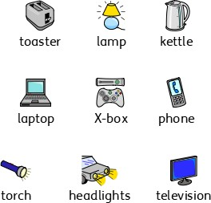
How does a  circuit work? | - A complete circuit is a loop that allows  electrical current to flow through wires.  - A circuit contains a battery (cell), wires and an  appliance that requires electricity to work (such as a bulb, motor or buzzer).  - The electrical current flows through the wires from the battery (cell) to the bulb, motor or buzzer).  - A switch can break or reconnect a circuit.  - A switch controls the flow of the electrical current around the circuit. When the switch is off, the current cannot flow. This is not the same as an incomplete circuit.
What are  electrical conductors and insulators? |  | - When objects are placed in the circuits, they may or may not allow electricity to pass through. Objects that are made from materials that allow electricity to pass through a create a complete circuit are called electrical conductors.  - Objects that are made from materials that do not allow electricity to pass through and do not complete a circuit are called electrical insulators. | 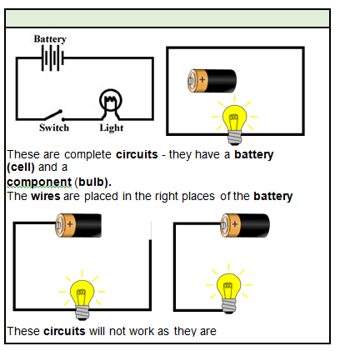  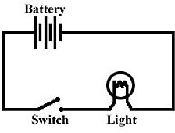  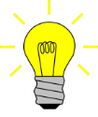  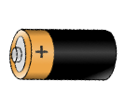  Diagrams  These circuits will not work as they are incomplete.  These are complete circuits - they have a battery (cell) and a  component (bulb).  The wires are placed in the right places of the battery for the  circuit to work.
Investigate
- Research how to work safely with electricity.
- Make a variety of circuits, investigating which circuits work and why.
- Name the basic parts including cells, batteries, wires, bulbs, switches, motors and buzzers.
- Draw circuits using pictorial representations (not circuit symbols).
- Create circuits using switches.
- Investigate which materials are electrical conductors and
insulators.
- Plan own investigation - e.g. Does the number of bulbs / batteries affect the brightness of the bulb?
 |  |  |  | Parklands Primary School - Science
 |  |  |  | Topic - Electricity |  |  |  |  | Year 4 – Strand - Physics
Question 1: Another name for a battery is: | Start of  unit: |  |  |  |  | End of  unit: |  | Question 7: Why is it dangerous to use an electrical appliance near water? |  | Start of unit: |  | End of unit:
circuit
light
buzzer
Question 2: Which of these need electricity to work? | Start of unit: |  |  |  |  | End of unit:
torch
mobile phone
games console
car
Question 3: How will you know if a  material conducts electricity? | Start of  unit: |  |  |  | End of  unit: |  |  | Question 8: A circuit will not work if….(tick three): |  |  | Start of unit: |  | End of unit:
Electricity will flow freely and the  circuit will work |  |  |  |  |  |  |  | There is no battery
 |  |  |  |  |  |  |  | There is no switch
The battery will not work |  |  |  |  |  |  |  | The switch is off
Electricity will not flow and the  circuit will not work |  |  |  |  |  |  |  | There is a break in the circuit
Question 4: Which of these are conductors of electricity? |  | Start of  unit: |  |  | End of  unit: |  |  | Question 9: When more batteries are added to a complete circuit… |  |  | Start of unit: |  | End of unit:
plastic comb |  |  |  |  |  |  |  | The light bulb does not go on
cardboard strip |  |  |  |  |  |  |  | The light bulb becomes brighter
aluminium spoon |  |  |  |  |  |  |  | The circuit does not work
copper coin |  |  |  |  |  |  |  | The switch goes off
Question 5: Which of these circuits will light? |  |  | Start of  unit: |  | End of  unit: |  |  | Question 10: Why will this circuit not work? |  | Start of unit: |  |  | End of unit:
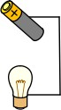 |  |  |  |  |  |  |  | 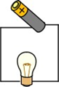
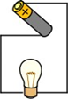
Question 6: Objects that are made from materials that do not allow electricity to pass through are called: |  |  | Start of unit: |  | End of unit:
conductors
insulators
batteries

