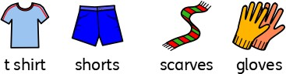
What will I know by the end of the unit?
What is a  season? | - There are four seasons  - Autumn - September, October, November  - Winter - December, January, February  - Spring - March, April, May  - Summer - June, July, August  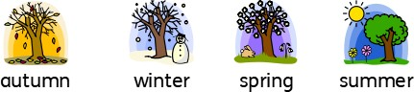
What happens in the  autumn?  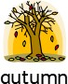 | - The temperature beings to fall, which means it gets  colder.  - The leaves on deciduous trees change colour and begin to fall to the ground.  - The days get shorter and the nights get longer.  - In the autumn, there are events such as Halloween and Bonfire Night.  - Things people might do are rake leaves, pick blackber- ries and collect conkers and pine cones.  - The weather may be slightly sunny, windy or rainy.  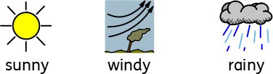  - The clothes you might wear include t-shirts and shorts on sunnier and warmer days, and woolly hats and scarves on colder days - especially as it gets closer to winter.
What happens in the winter?  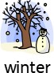 | - As the seasons change from autumn to winter it gets colder still - this is because the temperature has fallen.  - Sometimes, it can freeze overnight and in the mornings, there may be ice and frost.  - Deciduous trees have completely lost their leaves and the braches are bare.  - The days get shorter and the nights get longer. Winter has the shortest days and the longest nights of all the seasons.  - In the winter, there are events such as Christmas and Valentine’s Day.  - Things people might do are build snowmen, eat warm foods like stews and soups and light fires.  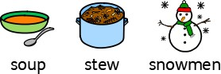  - The weather may be windy, rainy and chilly. Sometimes it also snows.  - The clothes you might wear include warm coats, jumpers, woolly hats and scarves on colder days.  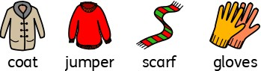

- Go on an autumn nature walk - what signs of autumn can you spot?
- Measure the temperature every day - what do you notice about the difference in temperature from the start of the unit to the end?
- Match events to the seasons they happen in? What is weather like during these events (e.g. Christmas Day, Halloween, Bonfire Night?)
- Discuss why it is good that fireworks happen in the autumn. What would happen if the happened in the summer?
- Discuss what happens when the children go home from school in the autumn and winter - what do they notice about daylight? Compare this to what happens in the summer.
- Analyse simple graphs that show how day length changes throughout the seasons.
- Research animals that hibernate or migrate in winter months.
Investigate!
Vocabulary
autumn | Autumn is the season between summer and  winter when the weather becomes colder and the leaves fall off the trees
chilly | very cold
cold | If it is cold, the temperature is very low
conkers | round brown nuts which come from horse  chestnut trees
day length | the amount of time where there is daylight.
daylight | Daylight is the natural light that there is during  the day, before it gets dark
deciduous | a tree that loses its leaves in the autumn  every year
freeze | When it freezes outside, the temperature falls  below 0 degrees.
frost | the ground becomes covered in ice crystals
hibernate | Animals that hibernate spend the winter in a state like a deep sleep
ice | Ice is frozen water
migrate | when animals move at a particular season from one part of the world to another
months | one of the twelve times of time that a year  is divided into
nature | the animals, plants, and other things in the world that are not made by people
rain | Rain is water that falls from the clouds in small  drops
season | the main times of year which can be divided and which have their own typical weather
slightly | a little bit
snow | soft white bits of frozen water that fall from the  sky in cold weather
spring | the season between winter and summer when the weather becomes warmer and plants start to grow again
summer | the season between spring and autumn when the weather is usually warm or hot
sunny | when the sun is shining brightly
temperature | a measure of how hot or cold something is
warm | when there is some heat but not enough to be hot
weather | what the sky and air outside are like, such as cold or sunny.
windy | when the wind is blowing
winter | the season between autumn and spring when the weather is usually cold

Parklands Primary School - Science
Topic: Seasonal Changes (Autumn and Winter) |  | Year: 1 | Strand: Physics
What should I already know?
- There are times when it is hot outside and there are times when it is cold outside.
- The months of the year.

d to the summer.

Parklands Primary School - Science
Topic: Seasonal Changes (Autumn and Winter) | Year: 1 | Strand: Physics
Question 3: In which season are you more likely to wear a coat, woolly hat and scarf? | Start of unit: | End of unit:
spring
summer
autumn
winter

Question 4: It always snows in winter. True or false? | Start of unit: | End of unit:
true
false

Question 2: The weather in  winter is usually…. (tick two) | Start of  unit: | End of  unit:
sunny
rainy
cold
hot

Question 1: Leaves begin to  fall from some trees in…. | Start of  unit: | End of  unit:
spring
summer
autumn
winter

Question 5: Complete this sentence with the words short and long to make it true. | Start of unit: | End of unit:
In the winter, the days are
and the nights are .

short long

