Parklands Primary School – Science
Topic: Animals including humans |  |  |  |  | Year 4
What do we already know? |  |  | Investigate  - Investigate the amount of sugar in drinks and learn how sugar leads to an increase in plaque and how this destroys tooth enamel.  - Compare the teeth of carnivores, omnivores and herbivores. What do you notice?  - Match animals to their teeth and explain your reasons for this.  - Identify the parts of the digestive system and explain their functions  - Make a model of the digestive system to show how each stage works. |  |  | Vocabulary  absorb soak up or take in  canine pointed teeth near the front of the mouth of humans and of some animals  carnivore an animal that eats meat  decay gradually destroyed by a natural process  digestion breaking down ingested food material  enamel the hard white substance that forms the outer part of a tooth  excretion the process of eliminating faeces, urine, or sweat from the body  faeces the solid waste substance that people and animals get rid of from their body by passing it through the anus  herbivore an animal that only eats plants  incisor the teeth at the front of your mouth which you use for biting into food  ingested When animals or plants ingest a substance, they take it into themselves, for example by eating or absorbing it  intestines the tubes in your body through which food passes when it has left your stomach  molar the large, flat teeth towards the back of your mouth that you use for chewing food  muscles something inside your body which connects two bones and which you use when you make a movement  nutrition the process of taking food into the body and absorbing the nutrients in those foods  oesophagus the part of your body that carries the food from the throat to the stomach  omnivore person or animal eats all kinds of food, including both meat and plants  organ a part of your body that has a particular purpose  plaque a substance containing bacteria that forms on the surface of your teeth  premolar two situated on each side of both jaws between the first molar and the canine  process a series of actions used to produce something or reach a goal.  Saliva the watery liquid that forms in your mouth and helps you to chew and digest food  Stomach the organ inside your body where food is digested before it moves into the intestines
- The parts of the human body and what they do.
- All animals need water, air and food to survive.
- The different ways in which humans are healthy.
- Animals get nutrition from what they eat.
- Humans and some animals have skeletons and
muscles for support, protection and movement.
- What carnivores, omnivores and herbivores are.
Excretion is one of the seven living processes
What will I know by the end of the unit
What is the role of our teeth and how do we look after them? | - Teeth are used for cutting and chewing food.  - They start the digestive process which gives us the energy we need to live.  - Humans look after their teeth by brushing and flossing and  ensuring that they do not eat foods high in sugar.  Not looking after teeth can lead to an increase in plaque and tooth decay.
What are the  different names and functions of human teeth? | 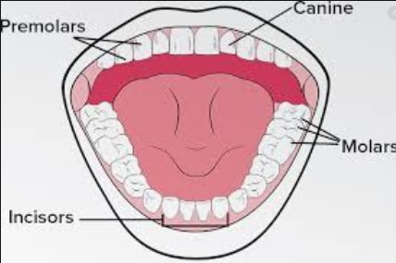  - Canines are pointed for tearing and ripping food - these are usually used when chewing meat.  - Incisors are shovel shaped and help bite lumps out of and cut food.  - Premolars and molars are flat and they grind and crush food
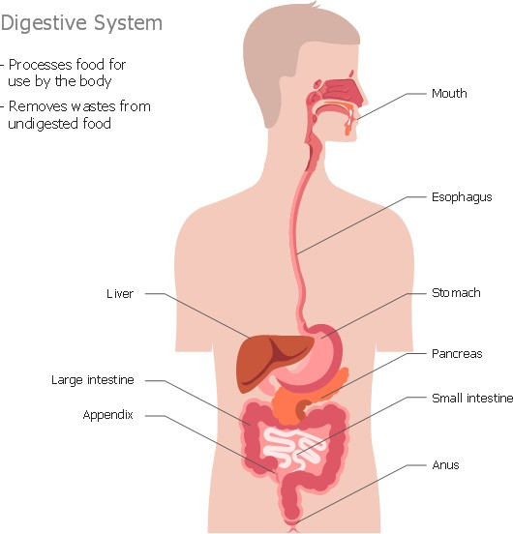
- Saliva is mixed with the food which helps to break it up.

- When the food is small enough to be swallowed, it is pushed down the
oesophagus by muscles to the stomach.

- In the stomach, food is mixed further.

- The mixed food is then sent to the small intestine which absorbs nutrients from the food.

- Any leftover broken down food then moves on to the large intestine.

- The food minus the nutrients arrives in the rectum where muscles turn it into faeces. It is stored here until it is pushed out by the anus. This is
called excretion.
Oesophagus
- The smell of food triggers saliva to be produced.

- The digestive system begins with the mouth and teeth where food is ingested and chewed.
The Digestive System

Parklands Primary School – Science
Topic: Animals including humans | Year 4

Question 1:  Place these in order of what happens in the digestive system. | Start of unit: | End of unit: |  | Question 2:  Which of these life processes takes place when  waste is pushed out? |  | Start of unit: |  | End of unit: |  |  | Question 3:  The substance that contains bacteria on the surface of your teeth is called… | Start of unit: | End of unit: |  |  | Question 4:  The substance that helps break down food in the mouth is… |  | Start of unit: | End of unit:
Teeth chew food and saliva helps the food to break down. |  |  |  | respiration |  |  |  |  |  |  | plaque |  |  |  |  | oesophagus
Any final nutrients are absorbed before waste is pushed out by the anus. |  |  |  | reproduction |  |  |  |  |  |  | canines |  |  |  |  | saliva
In the stomach the food is mixed further and then sent to the intestines |  |  |  | excretion |  |  |  |  |  |  | molars |  |  |  |  | nutrients
The food is pushed down the oesophagus to the stomach. |  |  |  |  |  |  |  |  |  |  | incisors |  |  |  |  | stomach
Question 5:  What carries food from the mouth to the stomach? | Start of  unit: | End of  unit: |  | Question 6: Tooth decay is when.. |  | Start of  unit: |  | End of  unit:
blood |  |  |  | teeth are used to chew
oesophagus |  |  |  | teeth are kept healthy
tongue |  |  |  | teeth are destroyed and damaged
teeth |  |  |  | teeth are brushed twice a day
Question 7: Label the types of teeth: incisors, molars, premolars, canines |  |  |  |  |  |  |  |  | Question 8: Name two ways in which we can look after our teeth. |  |  |  |  | Start of unit: |  |  | End of unit:

Question 9: Is this the skull of a carnivore, omnivore or herbivore? Explain how you know.  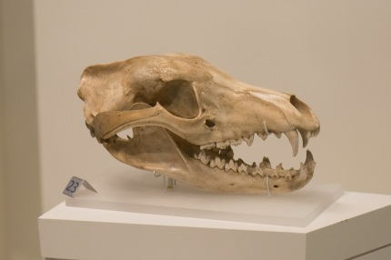 | Start of unit: | End of unit:
Question 10: Is this the skull of a carnivore, omnivore or herbivore? Explain how you know.  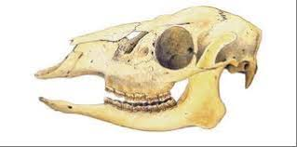 | Start of unit: | End of unit:

