Parklands Primary School - Science
Topic: Electricity | Year 6

What should I already know? | What I should know by the end of the unit.
- Electricity is a form of energy that can be carried by wires and is used for heating and lighting, and to provide power for devices.  - Sources of light and sound may need electricity to work.  - Where electricity comes from  - Which appliances need electricity  - What a circuit is, the components of a circuit and how it works.  - What electrical conductors and insulators are.  - What happens when a switch is added to a circuit.  - What forces and resistance are. | - How adding more cells affects the brightness of a bulb or the sound of a buzzer.  - How to draw circuit diagrams.  - How to explain why circuits do or don’t work.  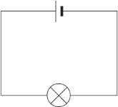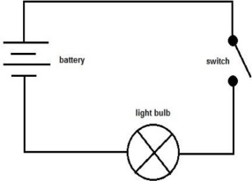  Diagrams

Scientific Learning and Enquiry
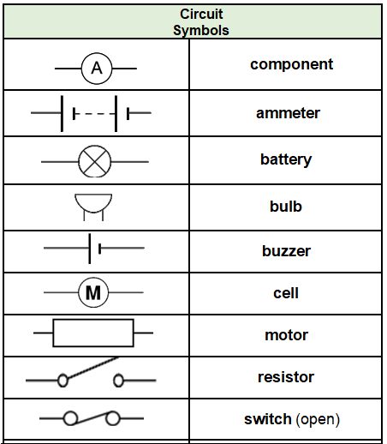 | - Match circuit symbols to their meanings and their words.  - Predict, then investigate what happens when more batteries are added to a circuit. Explain why this happens.  - Predict, then investigate what happens when more bulbs, motors are added to a circuit. Explain why this happens.  - Systematically identify the effect of changing one component at a time in a circuit.  - Use circuit symbols when representing a simple circuit in a diagram.  - Design and make a set of traffic lights, a burglar alarm or some other useful circuit.  - Investigate what happens when the voltage of the battery changes.  - Investigate what happens when the length of the wires changes.  - Investigate what happens when you add a resistor to a circuit.  - Use ammeters to measure the current in a circuit.
ammeter measures the current in a circuit  appliance a device or machine in your home that you use to do a job such as cleaning or cooking. Appliances are often electrical.  battery small devices that provide the power for electrical items such as torches  bulb the glass part of an electric lamp, which gives out light when electricity passes through it.  buzzer an electrical device that is used to make a buzzing sound  cell a synonym for battery  circuit a complete route which an electric current can flow around  component the parts that something is made of  conductor a substance that heat or electricity can pass through or along  current a flow of electricity through a wire or circuit  device an object that has been invented for a particular purpose  electricity a form of energy that can be carried by wires and is used  for heating and lighting, and to provide power for devices  energy the power from sources such as electricity that makes  machines work or provides heat | fuel a substance such as coal, oil, or petrol that is burned to provide heat or power  generate cause it to begin and develop  insulator a non-conductor of electricity or heat  mains where the supply of water, electricity, or gas enters a building  motor a device that uses electricity or fuel to produce  power power is energy, especially electricity, that is obtained in large quantities from a fuel source and used to operate lights, heating, and machinery  resistance a force which slows down a moving object or vehicle  source where something comes from  switch a small control for an electrical device which you use to turn the device on or off  voltage the force of an electric current as measured in volts  wires a long thin piece of metal that is used to fasten things or to carry electric current

Question 4: Explain what will happen if another bulb is added to a working  circuit. | Start of unit: | End of unit:

Question 5: Shorter wires will make bulbs brighter. True or False? | Start of unit: | End of unit:
true
false

Question 6: Explain what a conductor will do when added to a circuit. | Start of unit: | End of unit:

Question 3: Explain what will happen if another battery is added to a circuit  with a bulb. | Start of unit: | End of unit:

Question 7: A circuit will not work if…. (tick three): | Start of unit: | End of unit:
there is no battery
the switch is off
there is a break in the circuit
there is no switch

Question 2: Which of these circuits will light? | Start of unit: | End of unit:
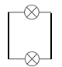
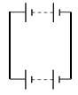

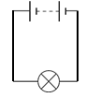

Question 1: Write the name for the component that each of these symbols represent. | Start of unit: | End of unit:
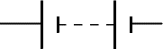
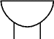
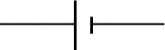

Question 8: What is the function of an ammeter in a circuit? | Start of unit: | End of unit:
measures the length of the wires in a circuit
measures the current in a circuit
measures how heavy the components are

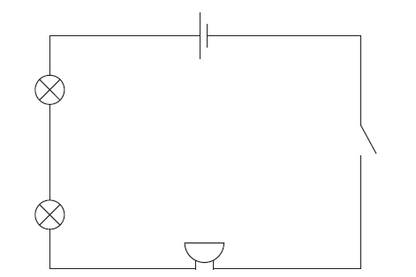  Question 8: Imagine you only have this equipment. Draw a circuit using circuit symbols featuring this equipment.  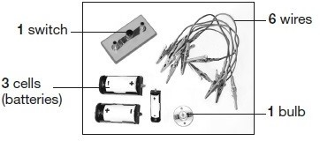 | Start of unit: | End of unit:

Question 9: Look at this circuit. The buzzer is currently not very loud. What could you do to make it louder? | Start of unit: | End of unit:

