Parklands Primary School
Topic-States of matter |  |  | Year 4 |  |  |  |  |  |  |  |  | Strand - Chemistry
What should I already Know? |  |  |  |  | What will I know at the end of the unit?
- Why some materials are used for certain purposes because of their properties  - The water cycle, and the processes of evaporation, condensation and precipitation. |  |  |  |  | What is a  particle? |  |  |  |  |  | - Particles are what materials are made from.  - They are so small that we cannot see them with our eyes.  - The properties of a substance depend on what its particles are like, how they move and how they are arranged  - Particles behave differently in solids, liquids and gases.
condensation small drops of water which form when water vapour or steam touches a cold surface, such as a window  cooling lowering the temperature of something  evaporation to turn from liquid into gas; pass away in the form of vapour.  freezing If a liquid or a substance containing a liquid freezes, it becomes solid because of low temperatures  freezing point The freezing point of a particular substance is the temperature at which it freezes. The freezing point of water is 0ºC.  gas a form of matter that is neither liquid nor solid. A gas rapidly spreads out when it is warmed and contracts when it is cooled.  heating raising the temperature of something  liquid in a form that flows easily and is neither a solid nor a gas.  melting to change from a solid to a liquid state through heat or pressure  melting point The melting point of a particular substance is the temperature at which it melts.  particles a tiny amount or small piece  precipitation rain, snow, sleet, dew, etc, formed by condensation of water vapour in the atmosphere  process a series of actions used to produce something or reach a goal.  properties the ways in which an object behaves  solid having a firm shape or form that can be measured in length, width, and height; not like a liquid or gas  temperature a measure of how hot or cold something is  vibrations when something vibrates, it shakes with repeated small, quick movements  water cycle the process by which water on the earth evaporates, then condenses in the atmosphere, and then returns to earth in the form of precipitation.  Water vapour Water in the gaseous state, esp when due to evaporation at a temperature below the boiling point. |  |  |  |  | What is a  solid?  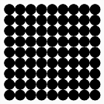 |  |  |  |  |  | - In the solid state, the material holds its shape.  - Solids have vibrating particles which are closely packed in and form a regular pattern.  - This explains the fixed shape of a solid and why it can’t be poured.  - Solids always take up the same amount space.
 |  |  |  |  | What is a  liquid?  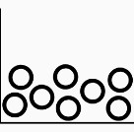 |  |  |  |  |  | - In the liquid state, the material holds the shape of the container it is in.  - This means that liquids can change shape, depending on the container.  - Liquids have particles which are close together but random.  - Liquid particles can move over each other.  - Liquids can be poured.
 |  |  |  |  | What is a  gas?  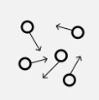 |  |  |  |  |  | - In the gas state, particles can escape from open containers.  - Gases have particles which are spread out and move in all directions.
 |  |  |  |  | What happens to the particles in water  when it is heated or cooled? |  |  |  |  |  | - When water (in its liquid form) is heated, the particles start to move faster and faster until they have enough energy to move about more freely. The water has evaporated into a water vapour.  - When water is cooled, the particles start to slow down until a solid structure (ice) is formed. The water has frozen.  - The temperature at which water turns to ice is called the freezing point. This happens at 0ºC.
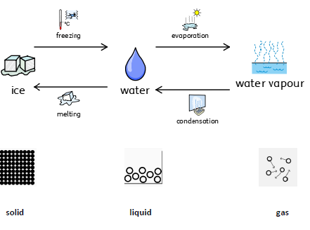  Diagram |  |  |  |  | What is the  water cycle?  (see separate knowledge organiser Geography - The Water Cycle) |  |  |  |  |  | 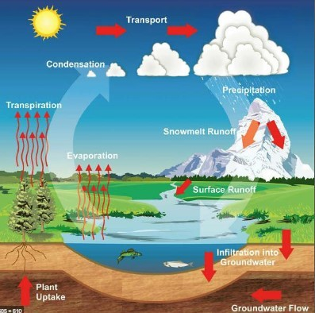
Investigate
- Group materials according to their states.
- Explain the particle structure of solids, liquids and gases.
- Explore the effect of temperature on substances such as chocolate, butter, cream. Compare their melting points and place them in a table.
- Research the temperature at which materials change state, for example, when iron melts or when oxygen condenses into a liquid.
- Observe and record evaporation over a period of time, for example, a puddle in the playground or washing on a line, and investigate the effect of
temperature on washing drying or snowmen melting.
- Analyse and interpret different forms of data (tables, graphs) to show the effects of temperature on states of matter.
- Present what you know about the water cycle using a variety of skills using appropriate vocabulary (The Water Cycle Knowledge Organiser).
- Observe evaporation and condensation in action by using bowls of water and mirrors /glass (The Water Cycle Knowledge Organiser).

Parklands Primary School
Topic-States of matter |  | Year 4 |  |  |  |  |  |  |  |  |  |  | Strand - Chemistry
Question 1: The particles in a solid: | Start of  unit: |  |  | End of  unit: |  |  |  | Question 6: Name the process that  describes the change from water to ice. |  |  |  |  |  |  | Start of unit: |  | End of unit:
are closely packed together and
vibrate
move freely over each other within a container in which they are held
can be poured
are very spread out and can escape an open container |  |  |  |  |  |  |  | Question 7: Write solid, liquid or gas to label each part of the diagram. |  |  |  |  |  | Start of unit: |  |  | End of unit:
 |  |  |  |  |  |  |  | 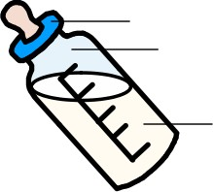
Question 2: The particles in a liquid (tick two): | Start of  unit: |  |  | End of  unit:
are closely packed together and
vibrate
move freely over each other within a container in which they are held
can be poured
are very spread out and can escape an open container
Question 3: The particles in a gas: | Start of  unit: |  |  | End of  unit: |  |  |  |  | Question 8: Match these changes to the  scientific name for the process. |  |  |  |  |  |  | Start of  unit: |  | End of  unit:
are closely packed together and  vibrate |  |  |  |  |  |  |  |  | 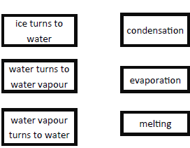
move freely over each other within a
container in which they are held
can be poured
are very spread out and can escape
an open container
Question 4: Match the states to their particle structure: | Start of unit: |  |  | End of  unit: |  |  |  |  | Question 9: Solids, liquids and gases have different properties. Indicate using an S, L or G, which state these properties apply to. |  |  |  |  |  |  | Start of unit |  | End of unit:
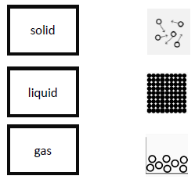 |  |  |  |  |  |  |  |  | keeps its own shape
 |  |  |  |  |  |  |  |  | can be poured |  |  |  |  |  |  | :
 |  |  |  |  |  |  |  |  | flows easily through a pipe
 |  |  |  |  |  |  |  |  | takes the shape of the container it is in
 |  |  |  |  |  |  |  |  | Can escape from an open container
Question 5: What is the freezing  point of water? | Start of  unit: |  |  | End of  unit: |  |  | . |  |  | Question 10: Explain why puddles get smaller after it has rained |  |  |  |  |  | Start of unit: |  | End of unit:

