Topic: Ancient Egyptians | Year: 4
Vocabulary
afterlife | a life that some people believe begins when you die, for example a life in  heaven or as another person or animal
ancient | belonging to the distant past, especially to the period in history before the end  of the Roman Empire (AD 410)
archaeologist | someone who studies the past by exploring old remains
architecture | the art of planning, designing and constructing buildings
artefacts | an object from the past that shows evidence of what life was like
chronology | the order of events in time
circa | Latin meaning ‘around’. c. 800 BC means around 800 BC.
civilisation | a human society with its own social organisation and culture.
climate | the general weather conditions that are typical of a place
continent | a very large area of land that consists of many countries. Europe is a continent.
culture | activities such as the arts and philosophy, which are considered to  be important for the development of civilisation
deities | a god or goddess
fertile | rich in nutrients to support the growth of many plants
hierarchy | a system of organising people into different ranks or levels of importance, for  example in society
hieroglyphics | symbols in the form of pictures which are used in some writing systems, for  example those of ancient Egypt.
irrigation | supply land with water in order to help crops grow
mummification | If a dead body is mummified, it is preserved, for example by rubbing it  with special oils and wrapping it in cloth
papyrus | a tall water plant that grows in Africa
pharaoh | a king of ancient Egypt
polytheists | the worship of or belief in more than one god
preserve | making sure that something remains as it is, and does not change or end
pyramids | ancient stone buildings with four triangular sloping sides. The most famous pyramids are those built in ancient Egypt to contain the bodies of their kings  and queens.
sarcophagus | a large decorative container in which a dead body was placed in ancient times
settler/  settlement | people who migrate to a new place. When people start a community, this is a  settlement
society | people in general, thought of as a large organized group
tomb | a large grave that is above ground
trade | the activity of buying, selling, or exchanging goods or services
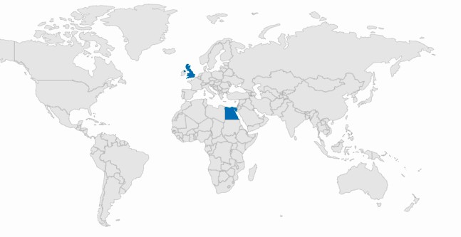
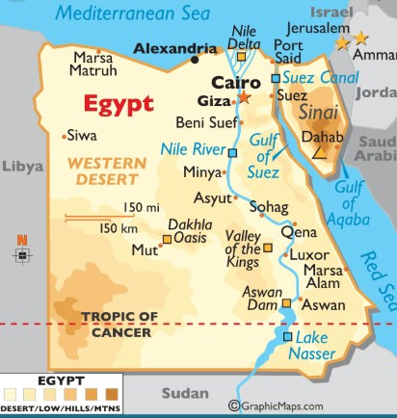
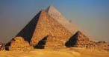
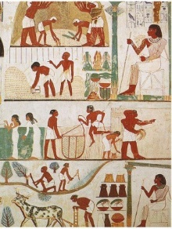
Timeline
1922: Howard Carter
discovers the tomb of Tutankhamun.
c. 2600 BC: Pyramid of
Giza built.
c. 3100 BC: Development
of hieroglyphics
c. AD 300: Last use of
hieroglyphic writing.
c. 2700 BC: First stone
pyramid built.
c. 3500 BC: Early
settlers settle in the Nile valley.
Egypt
UK
Diagrams
- The Nile was important because it provided water for crops but also fertile soil - this means that people settled near the banks of the Nile as it was considered a prime location. They were among the first civilisations to use irrigation systems.
- The Nile also provided mud for bricks and
pots, opportunities for fishing, papyrus
reeds and a key means of transport.
- We know about ancient Egyptian life be- cause of evidence such as the pyramids, the artefacts that were found there and methods of communications such as the use of hieroglyphics and papyrus rolls.
- Egyptian society was very hierarchical - this means that some groups of people were deemed more important than
others. Each group had a different role to play in Egyptian society.
- Mummification was the process of preserving a body - this process was very important to the Egyptians as they believed this would prepare the body for their journey into the afterlife.
- The bodies of important people, such as
pharaohs, were placed in these
pyramids, which were built as tombs.
- Religion was very important in Ancient Egypt. They were polytheists - they believed in different gods and
goddesses that were in charge of
different parts of their lives. These were
called deities.
Important Facts
- Egypt is a country in the continent of Africa.
- The climate of Egypt is different to that of the UK.
- Key human and physical geographical features.
- What life was like in Stone Age Britain.
What should I already know?

Historical Skills and Enquiry
- Describe how Egyptian artefacts and ruins tell us about their culture, and religious beliefs.
- Describe what Egyptian life was like for different groups of people.
- Describe how the Egyptian society has had an impact on modern society.
- Describe why people chose to settle in certain areas in ancient Egypt.
- Compare what was happening in the Egyptian civilisation with what was happening in Britain at the same time. Compare aspects of life such as achievements, society, beliefs, and architecture.
- Present what you know about the Egyptians using a variety of skills (e.g. Geography, English, Maths, Computing, etc)
- Use appropriate vocabulary to communicate about the Egyptians.

