History
Topic: The Romans |  |  | Year 4
What should I already know? |  | Historical Skills and Enquiry |  |  | Vocabulary
- The Stone Age was when early humans used tools from stone. This is also known as pre-history.  - The Stone Age had three periods - Palaeolithic (‘old’ Stone Age), Mesolithic (‘middle’ Stone Age) and Neolithic (‘new’ Stone Age).  - The Bronze Age was a period in time when humans used tools and weapons made from bronze - it began when the Beaker People arrived from Europe and brought with them new ways of doing things.  - The Iron Age was a period in time when people used tools and weapons made from iron.  - The United Kingdom is a country in the continent of Europe.  - The four countries of the United Kingdom.  - London is the capital city of England, a country in the United Kingdom. |  | - Describe what life was like for all groups of people during Roman Britain.  - Explain how Britain changed during Roman Britain using a timeline to help (e.g. explain how the Roman invasion brought an end to the Iron Age)  - Explain key leaders that influenced Roman Britain.  - Explain how we know about Roman Britain (e.g. artefacts, remains and historical accounts). Study Roman artefacts/tools and explain what their uses were.  - Compare the different periods of time you have studied so far (e.g. Stone Age, Bronze Age, Iron Age, Roman Britain). Explain similarities and differences.  - Describe the technology seen in Roman Britain.  - Explain what the Romans brought to Britain and explain the legacy that the Romans left to the British people.  - Describe the causes and consequences of the Roman invasion and then subsequently the causes and consequences of their return to Rome.  - Julius Ceasar and his significance |  |  | archaeologist someone who studies the past by exploring old remains  artefact an object from the past that shows evidence of what life was like  emperor somebody who rules an empire or is the head of state in an empire  empire a number of individual nations that are all controlled by the government or ruler of one particular country  fortress a castle or other large strong building, or a well-protected place, which is intended to be difficult for enemies to enter  influence to have an effect on  infrastructure the basic facilities such as transport, communications, power supplies, and buildings, which enable it to work  invasion to try and take over a place by force  Jutes people from the Jutland peninsula (Germany and Southern Denmark) who invaded Britain  legacy a direct result of something in history and which continues to exist after it is over  nation all the people who live in a particular country  Picts ancient tribes who lived in northern Scotland  province a large section of a country  Queen Boudica leader of the Iceni tribe who led a rebellion against the Roman invasion.  raid a sudden armed attack against a place  rebellion fighting back and opposing the people who have attacked you  Roman related to or connected with ancient Rome and its empire  Scots people from Ireland who eventually settled in Scotland  settler/  settlement people who migrate to a new place. When people start a community, this is a settlement  technology devices which are the result of scientific knowledge being used for practical purposes.  tribes a group of people of the same race, language, and customs
Ancient Greek Society
- In AD 44, The Romans capture Colchester. It is the first fortress in Roman Britain and made the capital city in AD 49.
- In AD 61, Queen Boudica led a rebellion
against the Romans.
- The Romans established themselves in Britain and developed:
  - paved straight roads
  - infrastructure (e.g. sewage)
- They also influenced the:
  - written and spoken language
  - measurement system
  - way of life
  - cities
  - buildings (built out of bricks and stone)
  - technology
  - religion (e.g. Christianity)
Roman Britain was a nation rather than a number of tribes.

History
Topic: Ancient Greece | Year 4
Map |  | Significant People  Julius Caesar and Boudicca
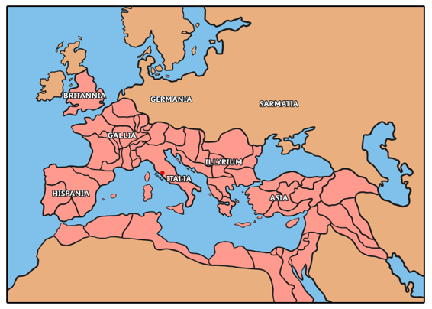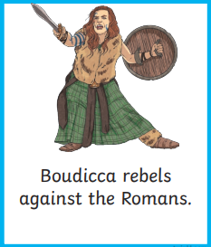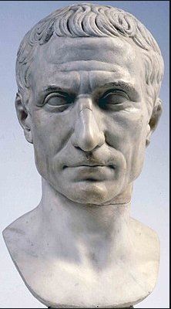

Timeline
AD 410: Romans
leave Britain to defend Rome
which was under attack. Angles, Saxons and Jutes make their way
from Germany and South Denmark.
c. AD 314: Christianity
becomes legal in the
Roman Empire.
c. AD 212: Roman Britain - a
plan was created to rule Britain. It is divided into two provinces.
c. 27 BC: Augustus c. AD 44: The Romans c. AD 100: London grows to become an
became the first capture Colchester. It is the important location in Britain. At the same time, elected emperor. first fortress in Roman Britain. the Colosseum, in Rome, was completed.
c. AD 250: Picts from Scotland, Scots from
Ireland, Angles, Saxons and Jutes from Germany and Scandinavia begin to threaten the Romans in Britain.
c. AD 80: Pompeii c. AD 122: Hadrian’s Wall is built
was destroyed by the to protect against the raiding
volcano, Vesuvius. Northern tribes, the Picts.
c. AD 43: The Romans
conquer Britain. This marks the end of the Iron Age.
c. 55-54 BC :
Julius Caesar first
invades Britain.
Question 1: Place these in order of chronology using the numbers 1-4. | Start of unit | End of unit
Iron Age
Bronze Age
Roman Britain
Stone Age
Question 2: Why did the Romans leave Britain? | Start of unit | End of unit
Rome was under attack so they went back to defend it
The Picts, Scots and Jutes led a successful invasion
They went back to help build the Colosseum
They didn’t want to be settled

Question 4: Somebody who rules an empire is  called…. | Start of unit | End of unit
an archaeologist
a settler
a Roman
an emperor

Question 3: Which year did the Romans  successfully invade Britain? | Start of unit | End of unit
2, 500 BC
54 BC
AD 43
AD 410

Question 5: Which word is closest to the  meaning of the word ‘invade’? | Start of unit | End of unit
trade
empire
retreat
raid
Question 6: Match these words to their definitions: | Start of unit | End of unit
Settle
To take over a place by
force or means of
attack
Invasion
Movement from one
place to another
Migration
To stay in one place
Question 8: Name one way in which the Romans were similar to the Beaker People.

Question 7: One way in which the Romans protected their towns was by: | Start of unit | End of unit

Question 9: Name one consequence of the Romans building paved roads in Britain. | Start of unit | End of unit
Question 10: Name four things that the Romans influenced during their time in Britain. | Start of unit | End of unit

