Parklands primary School
Topic – food chains and food webs year 4 Strand - Biology
What should I already know? | What will I know at the end of the unit?
- Animals can be grouped into carnivores, herbivores and  omnivores and other ways in which to classify animals.  - The differences between the teeth (incisors, molars, canines) of carnivores and herbivores.  - Examples of habitats (including microhabitats) and the animals and plants that can be found there.  - Plants need sunlight to grow.  - Living things depend on each other to survive.  - The seven life processes and that nutrition is one of them.  - Nutrition is the life process by which animals get energy.  How environments are changing. | - A food chain is a simple way to show the direction in which energy moves from the producer to the various consumers to the top or tertiary consumer.  - The producer (a plant) gets its energy from the Sun.  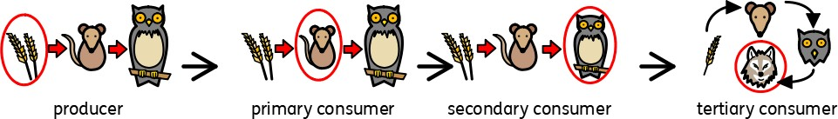  - In this example, the producer is the wheat, which gets its  energy from the Sun.  - The mouse eats the wheat and gets its energy from it. The mouse is the primary consumer.  - The mouse is then eaten by the owl, which is the secondary consumer. The owl gets its energy from the mouse. The owl is the predator and the mouse is the prey.  - The owl is then eaten by the wolf, which is the tertiary consumer. The wolf gets its energy from the owl.  The arrows show the direction in which the energy travels.
Vocabulary | What is a food web?
carnivore an animal that eats meat  classification key a system which divides things into groups or types  energy the ability and strength to do physical things  environment all the circumstances, people, things, and events around them that influence their life  food chain a series of living things which are linked to each other because each thing feeds on the one next to it in the series  food web a combination of food chains that integrate to form a network  habitat the natural environment in which an animal or plant normally lives or grows  herbivore an animal that only eats plants  incisor the teeth at the front of your mouth which you use for biting into food  life processes There are seven processes that tell us that living things are alive  microhabitat a small part of the environment that supports a habitat, such as a fallen log in a forest  molar the large, flat teeth towards the back of your mouth that you use for chewing food  nutrition the process of taking food into the body and absorbing the nutrients in those foods  omnivore person or animal eats all kinds of food, including both meat and plants  organism a living thing  predator an animal that kills and eats other animals  prey an animal hunted or captured by another for food  primary consumer an organism that feeds on producers . They are always herbivores.  producer organisms that make their own food using energy from the Sun.  Secondary consumer organisms that eat primary consumers for energy  tertiary consumer Tertiary consumers eat primary and secondary consumers as their main source of food | - A food web shows the direction in which energy travels when animals and producers (plants) are eaten by more than one thing.  - A food web shows multiple food chains where there are multiple feeding relationships.  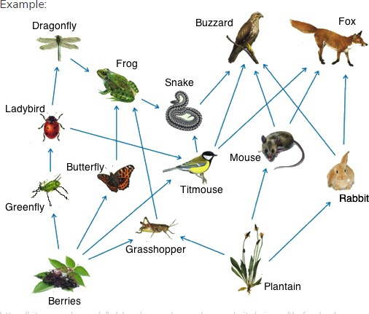  - When part of the food chain is removed, this has an impact on the other parts of the food chain. The number of some species will increase, while the population of others will decrease.  - This can have a direct impact on the survival of the species.  - The population of tertiary consumers depends on healthy populations of producers, primary and secondary consumers.
Investigate
- Match predators and their prey depending on their habitats.
- Create food chains for different habitats and compare them. How do the producers, predators and prey compare? What are their teeth like?
- Compare animal populations and explain why some populations (e.g. insects) might be higher than others (e.g. wolves)
- Explore what happens when part of a food chain is removed.
- Create food webs.

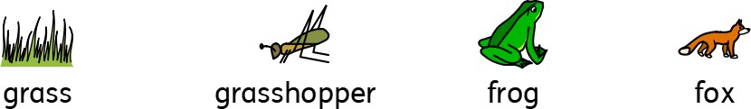
Question 1: Look at this food chain. Draw arrows to show the direction in which the energy travels.
These questions are based  on the food chain above. | Start of unit: | End of unit:
Question 2:
What is the producer in the food chain?
Question 3:
What is the primary consumer?
Question 4:
Give an example of a predator from the food chain.
Question 5:
Give an example of prey from the food chain.
Question 6: Which habitat would you find this food chain in?
Question 7:
What type of teeth would the fox have? Explain why.
Question 8:
A grasshopper is typically a herbivore. Explain what this means.
Question 9:
Name two things to this food chain that will happen if frogs become extinct.
Question 10:
Where do plants get their energy from?

