Parklands Primary School - Science
Topic: Light | Year 6

What should I already know? |  |  |  |  | What I should know by the end of the unit.
- Certain things produce light, usually by burning (e.g. the sun) or electricity (e.g. street lights)  - Shiny materials do not make light but do reflect it.  - Shadows are caused when certain materials block light.  - Light travels in straight lines. When light is blocked by an opaque object, a dark shadow is formed.  - The further away the light source is, the smaller the shadow is. The closer the source of the light, the bigger the shadow. |  |  |  |  | - How light travels to your eyes.  - The process by which we see.  - Why shadows are the same shape as the object that makes them.  - How a mirror works.  - How binoculars work.

Scientific Learning
How do we see? | 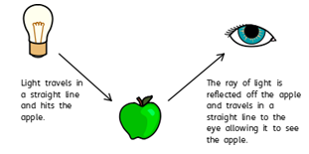 | How does  light  travel? |  | - Light travels in a straight line.  - When you place a torch on a table in a dark room, the beam  travels in a straight line.  - Reflection is when light bounces off a surface - this changes the direction in which the light travels.

Scientific Enquiry
- Because light travels in straight lines, when there is an opaque object blocking the light, a shadow is formed.  - These shadows have the same shape as the objects that cast them.  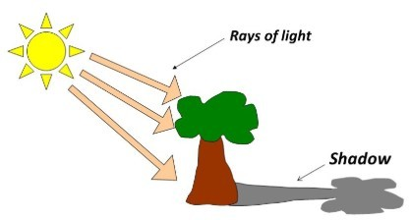  - The size of a shadow changes as the light source moves.  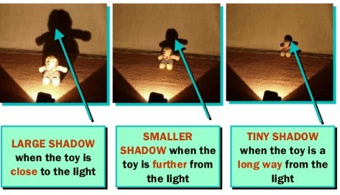 |  |  | - What happens when light is reflected from different surfaces? What happens when light is reflected from a mirror? What happens when the angle of the mirror (or light source changes?)  - Draw diagrams to show how light travels and what happens when light is reflected from a mirror.  - Draw diagrams to show how we see.  - Design an experiment to measure shadow length by changing a variable. Show your results in a line graph to show the relationship between distance of light  source and shadow length. Explain your findings using scientific vocabulary.  - Create shadow puppets to show how light travels and to demonstrate that a shadow has the same shape as the object that casts them.  - Make a periscope and explain how it works using diagrams and scientific  vocabulary. Use the idea that light appears to travel in straight lines to explain how it works.  - Research how mirrors are used in different contexts (e.g. rear view mirrors, on a dangerous bend) and explain why and how they work.  - Explain why objects look bent in water.  - Explore different contexts in which light travels including rainbows, colours  on soap bubbles and coloured filters.
angle the direction from which you look at something  dark the absence of light  dim light that is not bright  electricity a form of energy that can be carried by wires and is used for heating and lighting, and to provide power for machines  emits to emit a sound or light means to produce it  light a brightness that lets you see things  mirror a flat piece of glass which reflects light, so that when you look at it you can see yourself reflected in it no longer  has any living members, either in the world or in a particular place  opaque if an object or substance is opaque, you cannot see through it |  |  | reflects sent back from the surface and not pass through it  shadows a dark shape on a surface that is made when something stands between a light and the surface  source where something comes from  surface the flat top part of something or the outside of it  torches a small electric light which is powered by batteries and which you can carry  translucent if a material is translucent, some light can pass through it  transparent if an object or substance is transparent, you can see through it

Question 4: How do we see an  object? | Start of  unit: | End  of  unit:
Light reflects off the object and
enters our eyes
Light travels from our eyes and
reflects off the object
Light reflects off our eyes and
enters the object

Question 2: Shadows are formed when: | Start of unit: | End of unit:
light is let through an object
light reflects off an object
it is dark
light cannot travel through an
object

Question 1: When light bounces off a surface, it is: | Start of unit: | End of unit:
absorbed
dissolved
reflected
bounced

Question 3: The word that best describes an object that does not allow light to travel through it is: | Start of unit: | End of unit:
transparent
translucent
opaque

Question 5: A child says that a shadow takes the shape of the light source. Is this true or false? Explain your reasoning. | Start of unit: | End of unit:

Question 6: Describe how the mirrors in a periscope allow us to see. | Start of unit: | End of unit:
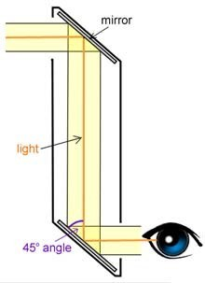

Question 7: You design an experiment to test the size of a shadow that is cast by a light source. Name one thing you will keep the same. Name one thing you will change. | Start of  unit: | End  of  unit:

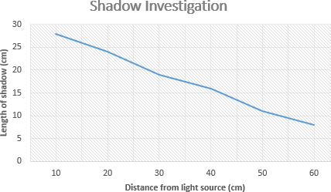
Question 8: Look at the graph above. What was the approximate length of the shadow when the object was 35cm away from the light source? | Start of unit: | End of unit:
Question 9: Look at the graph above. Approximately, how far away from the light source was the object when the length of the shadow was 25cm long? | Start of unit: | End of unit:
Question 10: Write a conclusion about what the line graph is showing using scientific vocabulary. | Start of unit: | End of unit:

