History
Topic: Stone Age to Iron Age |  |  | Year 3
What should I already know? |  | Bronze Age to Iron Age |  |  | Vocabulary
- Life existed before your grandparents were born.  - Millions of years ago, dinosaurs lived.  - Evidence of this was found by Mary Anning, who discovered fossils.  - What climate means and an example of it. |  | The Bronze Age  - The Bronze Age started at different times around the world.  - Tools were made from bronze - copper and tin were heated up and poured into casts.  - Evidence of the Bronze Age:  - Amesbury Archer - the remains of an early Bronze Age man who was buried with over 100 artefacts  - Discovery of round barrows and stone circles  - The Bronze Age started when the Beaker People arrived from Europe.  - They brought with them new ways of making metal.  - Bronze Age people lived in settlements, which was a group of round houses.  - Houses were made from wattle (sticks) and daub (mud) or dry stone.  - Settlements traded resources like copper and tin.  - Burials were important to Bronze Age people - they placed stone circles where burials took place.  The Iron Age  - Tools were made from iron. Iron was heated up then the hot iron was ham-  mered into shape.  - Settlements became larger because tribes were better able to farm and defend themselves.  - At the end of the Iron Age, coins were made and used as currency.  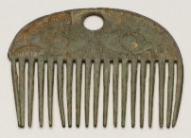  - There were lots of battles between tribes who fought each other for more land and power.  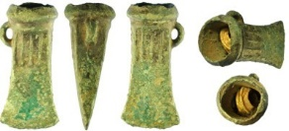 |  |  | ancient belonging to the distant past, especially to the period in history before the end of the Roman Empire.  Archaeologist someone who studies the past by exploring old remains.  Artefact an object from the past that shows evidence of what life was like.  Barrow a large structure made of earth that people used to build over graves.  Believe Bronze Age people held religious gatherings, usually around burials. Iron Age people believed in powerful spirits.  Bronze copper and tin are melted together to make a metal called Bronze.  Century a period of 100 years.  Circa latin meaning ‘around’ .c. 800 BC means around 800 BC.  Civilisation a human society with its own social organization and culture.  Climate the general weather conditions that are typical of a place.  Discovery if someone makes a discovery, they are the first person to find or become aware of a place, substance or scientific fact that no one knew about before.  Druids powerful religious people.  Era a period of time in history. An era often begins or ends with an  important event.  Extinct no longer has any living members, either in the world or a particular  place.  Farming when an area of land is used to produce crops or to breed animals and  livestock.  Flint a piece of stone used in fire-starting and as a tool.  Gather collect things together.  Hearths the floor of a fireplace, or the stone or brick area in front of it.  Hillfort settlements built on hills to provide more protection.  Invasion to try and take over a place by force.  Island a piece of land that is completely surrounded by water.  Land clearance the removal of trees, or other things that are not wanted from an area  to clear the land.  Loom an apparatus that makes fabric using threads.  Mesolithic Middle Stone Age.  Migration movement from one place to another in order to settle there.  Neanderthal an early species of human being, now extinct.  Nomad a person or a group of people with no fixed home who travelled around  to find shelter.  Palaeolithic Old or ‘ancient’ stone age.  Rampart a defensive wall built for protection.  Remains traces of the past.  Resources something used to help when needed.  Sacrifice offerings to spirits such as weapons, animals and humans.  Settler/ people who migrate to a new place. When people start a community  settlement that is a settlement.  Stone circle burials took place in stone circles.  Trade the activity of buying, selling or exchanging goods or services.  Variety things which are different from each other.
What was the Stone Age?
- The Stone Age began when the first tools were made from stone and ended with the introduction of metal tools.
- At the end of the Ice Age, the sea levels rose and so Britain turned into an island.
- Humans survived by using sharp stone tools to kill animals, such as mammoths.
- Dead animals proved to be useful
resources because they provided food to eat and skins to keep warm. Their bones were another useful material for making tools.
- Evidence of the Stone Age includes discoveries of: cave paintings, early tools, fire hearths, settlements and Cheddar Man.
- At the same time in another part of the world was the Egyptian civilisation - the Egyptians were building the pyramids around the same time as the Neolithic era.
Key Events in the Stone Age
65 Million Years Ago | Dinosaurs existed
c. 800,000 BC – 10,500 BC.  Palaeolithic Stone Age.  (Old or Ancient Stone Age) | Neanderthals and modern humans used ancient tools and simple ways of living to survive the Ice Age.
c. 10, 500 BC - 4, 000 BC  Mesolithic Stone Age.  (Middle Stone Age) | Middle Stone Age: from the end of the Ice Age, as the climate got warmer, to the start of farming. Humans would demonstrate a variety of ways to gather food including hunting and fishing.
c. 4, 000 BC - 2, 500 BC  Neolithic Stone Age (New Stone Age) | New Stone Age: from the start of farming including land clearance and the keeping of animals. This lasted till the first use of metal.

History
Topic: Stone Age to Iron Age | Year 3
Significant Places and Objects | Historical Skills and Enquiry
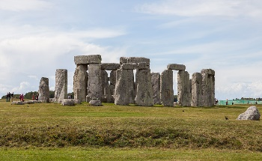  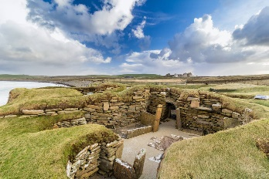  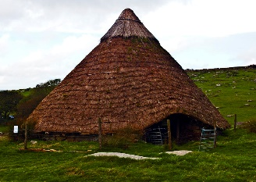  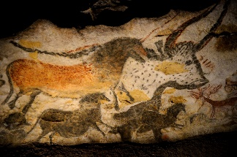  Bronze Age Hut  Cave Art (Lascaux, France)  Stonehenge – Amesbury, England  Skara Brae – Orkney Islands, Scotland | - Describe what life was like for all groups of people during all three stages of the Stone Age, the Bronze Age and the Iron Age.  - Use word mats to understand the meaning behind the words, Palaeolithic, Mesolithic and Neolithic.  - Ask questions and find out the answers about the Stone Age, Bronze Age and Iron Age.  - Explain how Britain changed during the Stone Age, Bronze Age and Iron Age using a timeline to help.  - Explain how we know about the Bronze Age and the Iron Age.  - Study Stone Age, Bronze Age and Iron Age artefacts/ tools and explain what their uses were.  - Place events on a timeline using dates.  - Compare the Stone Age, Bronze Age and Iron Age using Venn Diagrams.  - Explain what religious beliefs were like during this time.  - Look at pictures of Skara Brae and describe the features of the settlement.  - Present what you know about the Stone Age using a variety of skills (e.g. Geography, English, Maths and Computing).  - Explain how the Roman invasion brought an end to the Iron Age.
Timeline
c. 55-54 BC Julius Caesar first invades Britain.
c. 2,300 BC: Bronze Age begins when the beaker people begin to arrive in Britain.
c. 10, 500 BC - 4, 000 BC
Mesolithic Stone Age
c. AD 43 The Romans conquer Britain. This marks the end of the Iron Age.
c. 80 BC Coins are thought to be first used.
c. 1, 000 BC: The cart with wheels is invented.
c. 4, 000 BC - 2, 500 BC
Neolithic Stone Age
c. 800, 000 BC - 10, 500 BC:
Palaeolithic Stone Age
c. 800 BC: The Iron Age Begins.

Question 1: Using the numbers 1-3, put these in the order in  which they happened. | Start of unit: | End of unit:
Mesolithic
Palaeolithic
Neolithic
Question 5: Using the numbers 1-3, put these in the order in which they happened. | Start of unit: | End of unit:
early humans use tools such as
flints to help them survive
the start of farming
the start of hunting and
gathering
Question 9: Which year did the Bronze Age start? | Start of unit: | End of unit:
2, 500 BC
0
AD 43
AD 2, 500
Question 10: How did Iron Age people protect their settlements? Tick two | Start of unit: | End of unit:
trade
migration
hillforts
ramparts
Question 2: Stone Age humans lived at the same time as dinosaurs. True or  False? | Start of unit: | End of unit:
True
False

Question 6: Why were animals important to Stone Age humans? Tick all that are true. | Start of unit: | End of unit:
they provided them with food
they used their bones to make
tools
they used their skins to keep
warm
they loved being around all kinds of animals
Question 3: Which of these is an  example of a Stone Age settlement? | Start of unit: | End of unit:
Sudbury
Skara Brae
London
Great Cornard

Question 7: Place these in order of chronology using the numbers 1-4. | Start of unit: | End of unit:
The cart with wheels is invented
The Romans invade Britain
Beaker People arrive
Iron Age begins
Question 10: A settlement is... | Start of  unit: | End of  unit:
where people were buried
where people hunted
where people migrated to, to
live in a community
where people migrated from
Question 11: The Iron Age ended in… | Start of  unit: | End of  unit:
800 BC
43 BC
AD 43
AD 800

Question 4: Give an example of evidence that tells us about the Stone Age. | Start of unit: | End of unit:
Question 8: What is bronze  made out of? Tick two. | Start of  unit: | End of unit:
gold
silver
copper
tin

