Parklands Primary School - Science
Topic: Living Things and their Habitats | Year 6

What should I already know? |  |  | What Should I Know?
- Animals can be grouped into carnivores, herbivores and omnivores. They can also be grouped into vertebrates and invertebrates.  - Organisms can be classified and we can use a classification key to identify them.  - Examples of habitats (including microhabitats) and the organisms that can be found there.  - Living things depend on each other to survive.  - How environments are changing and how changes endanger living things.  - The relationships between predators and prey.  - How the life cycles of mammals, amphibians, insects and birds differ.  - How animals reproduce and the difference between sexual and asexual reproduction in plants.  - Food chains demonstrate the direction in which energy travels.  - How organisms have adapted and evolved over time. |  |  | - Living things can be grouped according to different criteria (where they live, what type of organism they are, what features they have). For example, a camel can belong in a group of vertebrates, a group of animals that live in the desert, and a group of animals that have four legs.  - A classification key is a tool that is used to group living things to help us identify them using recognizable characteristics.  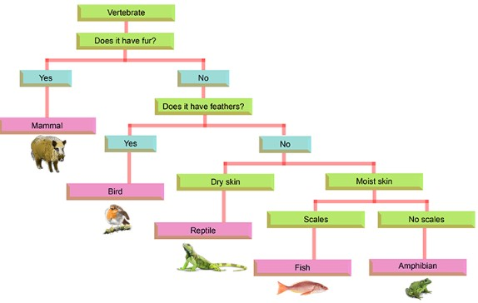  - The Linnaean system, named after Carl Linnaeus, has  different levels where the number of living things in each group  gets smaller and smaller, until there will just be one type of animal in the species group.  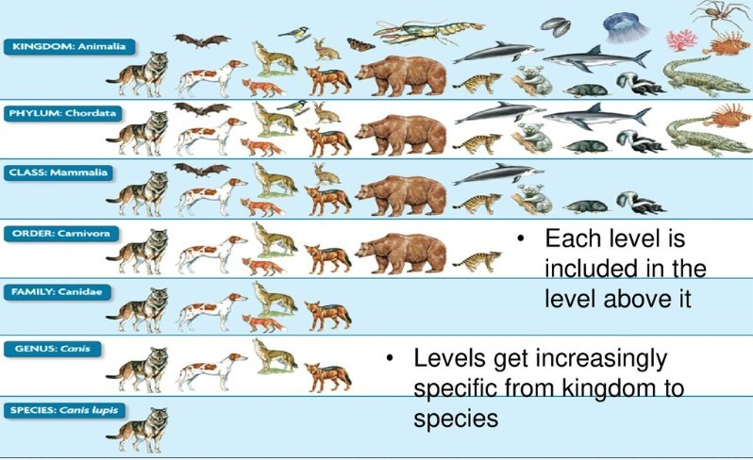
Scientific Learning
What are microorganisms? | - Microorganisms are very tiny organisms where a microscope has to be used to see them.  - Examples of microorganisms include dust mites, bacteria and fungi, such as mould.  - Some microorganisms can be helpful in certain situations. Others can be harmful, and their spread needs to be controlled or contained.
Scientific Enquiry
- Sort vertebrate and invertebrate animals into groups, describing their key features.
- Use a classification key to identify which group of vertebrate animals belong to
and then create your own.
- Explore the different ways in which invertebrates can be classified (e.g. arachnids, insects, molluscs).
- Describe some organisms that may be difficult to classify (e.g. platypus) and explain why.
- Sort scenarios where microorganisms might be helpful (e.g. yeast in baking) or harmful; (e.g. infectious diseases).
- Use classification systems and keys to identify some organisms in the immediate environment. Record these in a variety of ways (e.g. Venn and Carroll diagrams, tables)
- Research unfamiliar organisms from a broad range of other habitats and decide where they belong in the classification system.
- Research the work of Carl Linnaeus.
 |  |  | What I should know by the end of the unit.
- what a vertebrate and an invertebrates is.
- the features of a mammal.
- the features of a bird and reptile.
- the features of an amphibian and fish.

adaptation a change in structure or function that improves the  chance of survival for an animal or plant within a given  environment  carnivore an animal that eats meat  characteristics the qualities or features that belong to them and make  them recognizable  classification key a system which divides things into groups or types  criteria a factor on which something is judged  energy the ability and strength to do physical things  environment all the circumstances, people, things and events around  them, that influence their life  evolution a process of change that takes place over many generations, where species of animals, plants, or insects slowly change some of their physical characteristics  food chain a series of living things which are linked to each other because each thing feeds on the one next to it in the series |  | habitat the natural environment in which an animal or plant  normally lives or grows  herbivore an animal that only eats plants  invertebrate a creature that does not have a spine, for example an  insect, a worm, or an octopus  microhabitat a small part of the environment that supports  a habitat, such as a fallen log in a forest  microorganism a very small living thing which you can only see if you  use a microscope  mini beast a small invertebrate animal such as an insect or spider  omnivore person or animal eats all kinds of food, including  both meat and plants  organism a living thing  predator an animal that kills and eats other animals  prey an animal hunted or captured by another for food  species a class of plants or animals whose members have the same characteristics and are able to breed with each other  vertebrate a creature which has a spine

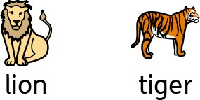

Question 1: Which of these is not a vertebrate? | Start of unit: | End of unit:
bird
mammal
reptile
insect
amphibian

Question 2: Give an example of a  microorganism. | Start  of  unit: | End  of  unit:

Question 3: Name one thing that makes these animals similar and one thing that makes them different. | Start of unit: | End of unit:
similar different

Question 4: Give an example of when microorganisms are helpful. | Start of unit: | End of unit:

Question 5: Give an example of when microorganisms are harmful. | Start of unit: | End of unit:

Question 6: Give an example how food is preserved to stop it from going mouldy. | Start of unit: | End of unit:

Question 7: What is Carl Linnaeus famous for and why is his work important? | Start of unit: | End of unit:

Question 8: Use the classification key to identify which plant these leaves have come from. | Start of unit: | End of unit:
How many leaves on each branch?

Multiple leaves A single leaf

Are there ten or more leaves on the branch? Does it have a smooth or uneven edge?
Yes No Smooth Uneven

Ash Beech
Oak

Do the leaves meet at a
single point on the branch
or are they spread out along it?

Single Spread out
point
Horse Chestnut Elder

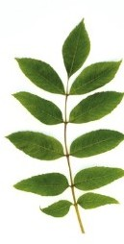
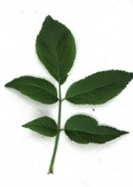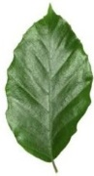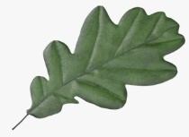

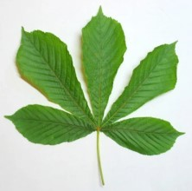

Question 9: This is a holly leaf. Choose a leaf from the ones above that it is similar to and give reasons why. | Start of  unit: | End of  unit:
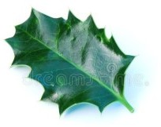

Question 10: Create your own classification key to sort the following animals. It has been started for you.  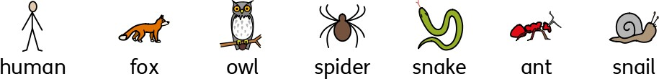 | Start of unit: | End of unit:
Does it have a spine?

Yes (vertebrate) No (invertebrate)

