Westbury Park School
Bayswater Avenue, Bristol BS6 7NU

OUTCOMES | AIM | Our Long term vision and goals |  | Living healthy and well  Every child is cared for and has the capacity to be more caring themselves |  | Learning skills for Life  Every child has the skills and self confidence to make positive choices | Love of Learning  Every child has a positive attitude to learning and achieves the  best they can | Learning environment  Every child works in an environment that is conducive to learning and reflects the school's ethos | Looking beyond the horizon  Every child is part of the wider educational picture and benefits from collaboration
 | OBJECTIVES  TARGETS | The specific targets to achieve these aims |  | Every child can recognise and respond to what is appropriate behaviour in school and at home by:  - Learning to regulate their own behaviour and feelings appropriately  - Establishing and maintaining good relationships with peers and others  - Identifying what bullying is and where to get help from if needed  - Knowing what is needed to be healthy through exercise and diet  - Recognising the signs of stress in themselves and others and know what to do to help  - Knowing how to recognise potentially unsafe situations and take appropriate action  - Being able to access more support when it is needed through school and signposting to other agencies |  | Every child understands themselves well and can identify with a local, national and global community by:  - Understanding what it means to have a Growth Mindset and be willing to learn from mistakes  - Being supported to take risks and become more resilient in learning and in life  - Being well-prepared for physical and emotional change in the future  - Recognising discrimination and radicalisation and knowing how to challenge it  - Having a good understanding of how to manage money  - Developing an identity as a member of a Westbury Park house  - Developing awareness of the rights and responsibilities of being a World and British Citizen | Every child is able to demonstrate an independent, deep love of learning and make links between subjects by:  - Developing thinking skills and philosophical thought  - Learning through a broad and balanced curriculum that enables deep thinking to take place  - Focusing on mastering English and maths skills that can be applied widely to different contexts  - Focusing on music, art and creativity  - Being provided with opportunities to extend and develop learning in English and maths  - Being given early intervention to secure phonics, literacy and maths skills if needed  - Using ICT as a tool for learning to give access to a world of knowledge and promotes science and technology | Every child works and plays in an environment that is fit for purpose and reflects the school's commitment to quality by:  - Creating new play areas for Early Years and in the Keystage 1 playground to provide challenge and creative play opportunities  - Improving the school hall so that it can be used more flexibly and creates a pleasant place in which to eat  - Refurbishing the Early Years space to be fit for purpose, including improving ICT facilities  - Refurbishing toilets and washing facilities across the school to improve hygiene and health  - Creating additional group rooms and a library to enhance learning  - Providing high quality school meals | Every child is part of an organisation that is making a significant contribution to improving outcomes for all children by:  - Developing new ways of collaborating with other schools in the North West of Bristol  - Sharing good practice from our school with other schools to help raise standards  - Training aspiring middle leaders through courses at this school in the first year and in other institutions in the second year  - Creating a sustainable model of school organisation that ensures succession planning is in place for key leadership roles  - Developing links with secondary schools and universities to enhance action research projects
PROVISION | EDUCATIONAL STRATEGY | What are we going to do to reach meet these objectives? |  | - Give children opportunities to express concerns and learn resilience strategies through weekly circle time  - Put in place a structured PSHE curriculum that focuses on fostering positive relationships, including mindfulness training  - Introduce a curriculum strand to teach awareness of healthy eating and exercise  - Monitor transition points [end of EY, Year 2, Year 6] effectively  - Pupil Progress meetings focus on whole child's development, including attendance and lateness  - Expand Gingerbread Club to allow access to more self esteem support  - Behaviour code is enforced and parents are involved early in process  - Identify routes for family support |  | - Teach children the principles of Growth Mindset and the importance of being resilient learners, including inspirational speakers  - Use the Six School Values to underpin teaching in Collective Worship and Class Assemblies  - Challenge children to take risks and support learning as a consequence  - Support children in making mistakes and learning from them  - Deliver high quality Sex and Relationship Education to prepare children for next stage of life  - Develop PSHE units on values, managing money and being aware of radicalisation issues [Years 5 &6]  - Promote Rights Respecting Schools Award [RRSA] levels 2 and 3  - Create responsibility post for developing the house system | - Curriculum design takes into account the value of music, art and drama, whilst maintaining the best of the current curriculum plans  - Develop marking and feedback to ensure that children are able to prove their learning by application  - Enabling children who need early intervention to be targeted with teacher led interventions to close the gap in learning  - Ensuring vulnerable groups of children are given targeted support with teacher led interventions to close the gap  - Develop teaching and learning reviews to enhance quality of teaching and learning further  - Tracking progress in year effectively to ensure progress is made  - Using data to identify trends and show where there may be challenges | - Utilise opportunities for external funding streams to enable follow through of aims for improving the learning environment  - Budget for some improvement each year as well as repairs and maintenance  - Reviewing provision of school meals and maximising quality of food, service and environment when current contract expires  - Draw up plans for re-developing Early Years teaching areas and outside space to create facilities that are fit for purpose  - Draw up plans to complete improvements to play areas, including additional play space for Keystage 1  - Draw up plans for improving the hall, library and toilets, group rooms and front of school areas | - Collaborate with North Bristol schools in creating a structure for school improvement and accountability  - Share good practice through the North Bristol schools structure  - Develop shared staff training opportunities amongst North Bristol schools  - Continue to offer aspiring middle leadership course and oppor-tunities to lead specific projects related to school improvement  - Keep abreast of changes in Ofsted inspection frameworks and the role of the Regional Schools Commissioner  - Seek collaboration with academic  institutions to develop action research work in school  - Develop links with Redland Green School
 | AIM |  |  | Living healthy and well |  | Learning skills for life | Love of learning | Learning environment | Looking beyond the horizon
PROVISION | RESOURCE  STRATEGY |  | What will we need in order to meet these objectives? | - Structured PSHE curriculum plan in place  - Gingerbread Club funding and staff trained appropriately  - Appoint parent liaison worker to support vulnerable families  - Prioritise funding for offsite sports and co-ordination of activities  - Funding for PP champion continues |  | - Training for all staff in principles and practice of Growth Mindset  - Fund resources and assessment for RRSA levels 2 and 3  - Residential visit enabling fund  - Teacher focus on identifying risk taking and learning from mistakes in marking and feedback  - Responsibility post for houses | - Review curriculum to ensure that creativity is enhanced through themed days and enrichment weeks  - Prioritise developing ICT by increasing range and quantity of devices  - Funding teacher-led intervention programmes  - Responding flexibly to new assessment requirements | - Dedicated person to apply for alternative funding streams to facilitate improvements  - Continue to apply for DfE grants  - Budgeting to include an element of improvement as well as repairs and maintenance  - Plans for hall, group room and toilet improvements | - Time for members of Senior and School Leadership team to engage with North Bristol schools to offer and receive school improvement strategies  - Time for aspiring middle leaders to develop action research projects to drive school improvement  - Diversification of income streams
 | MILESTONES |  | What steps will we need to take by 31st March each year to make sure we meet these objectives? | 2016 | Circle time and PSHE is embedded in school culture.  Gingerbread Club expanded with trained staff | Training for all staff and Governors on Growth Mindset takes place  Create responsibility post for houses  RRSA level 2 preparation completed | New tracking and assessment systems accurately monitor children's progress  ICT strategic plan for whole school 2016 to 2019 is prepared by ICT leader | Refurbish EY rooms and group rooms above Year 2 and school hall upgraded. Playground development plans in place | Full involvement as a strategic partner in school improvement and accountability for North West Bristol schools. Succession plan in place
 |  |  |  | 2017 | Family liaison worker appointed to support families  Review of transition points to identify further improvements | Higher level training for staff to implement Growth Mindset  RRSA level 2 achieved  Teaching on radicalisation/values | Curriculum review identifies areas of strength and development once new National Curriculum is embedded in school practice | Develop Keystage 1 and EY play areas to create attractive play areas for imaginative and creative play. Attract funding to re-develop the library | Middle leaders course offered beyond the school to other aspiring middle leaders in North West Bristol schools
 |  |  |  | 2018 | Develop school grounds to enable children to grow own plants  Conflict resolution training | Teaching on radicalisation and values is embedded in curriculum  Preparation for level 3 of RRSA  Review of inspirational speakers | Monitoring of progress of vulnerable groups, including Black Caribbean children, shows that progress is good  Music, art & creativity enrichment week | Attract external funding to re-develop toilets and washing facilities in main building, including facilities for the disabled and improved accessibility | Developed links with other schools, especially Redland Green School, improve transition and collaboration enhances learning experiences
 |  |  |  | 2019 | Evaluate behaviour and discipline policies  Focus on healthy eating in enrichment week | Re-visit school values and adapt or change as needed  RRSA level 3 achieved  Review SRE curriculum resources | Develop further opportunities for music, art and creativity  Review STEM across the curriculum and through a range of enrichment activities | Attract external funding in order to  create additional break out rooms for small group teaching and 1:1 interventions | Strategic development of collaborative structures enable the school to contribute to school improvement more widely
 |  |  |  | 2020 | Absence recording is automated to improve accountability  Mindfulness training for staff | Child conferences on Growth Mindset and learning from mistakes  Determine new framework for teaching about money matters | New ICT strategic plan for 2020 to 2022 is prepared by ICT leader  Impact assessment of confidence and depth of learning by child conferencing | Attract external funding to re-develop the hall and serving areas to create more storage space and improve access to the hall for community use | School plays an increasingly significant role in school improvement and accountability that benefits many children
 | QUALITY CHARACTERISTICS  (SUCCESS CRITERIA) |  | How will we know when these objectives have been met and we can celebrate? | - Behaviour is improved by early intervention [Parent Questionnaire /Child Voice]  - Children actively take part in PSHE lessons and understand how to be safe in the real and virtual world  - Circle time is embedded across the school and is effective  - Children and parents manage transition points successfully and feel confident moving to a new phase of the school or beyond  - Parents can access early support in school and be signposted to further support if needed  - Absences and lateness is reduced and support in place to help families manage this better  - Gingerbread Club is expanded so that more children can benefit from self esteem and mindfulness techniques to improve social skills |  | - All children are confident to talk about taking risks in their learning and learning from mistakes  - Residential visit feedback shows that these have developed resilience and Growth Mindset from children and parents  - Marking and feedback shows children taking risks and learning from mistakes in learning  - The house system is overhauled and is effective in promoting a greater sense of identify and belonging  - RRSA levels 2 and 3 are achieved on time and embedded in school culture  - Teaching of SRE, money matters, radicalisation and values is embedded in the curriculum and a clear progression of concepts can be mapped across the school | - Child conferences show that children are confident and deep learners who can apply skills to new situations  - Challenging annual targets for progress and attainment are set and met  - Children are given opportunities to develop their learning in English and maths with specialist teachers  - Children who need intervention programmes are able to access these quickly and effectively  - Vulnerable groups make good progress and almost all meet age related expectations  - Black Minority Ethnic achievement is better than national BME outcomes  - A robust and effective tracking system is in place to identify early challenges and the Pupil Progress Meeting programme identifies ways to provide appropriate support | - Learning environment meets the needs of the school community and enables maximum use to be made of the available space  - Playtimes are improved because there are a wider and better range of play opportunities  - Lunchtimes are improved by fresh and locally produced food being cooked to a high standard by dedicated school chef  - Learning spaces are fit for purpose and have appropriate ICT infrastructure in place to support learning  - Disabled access is improved and is clearly identifiable as a priority across the school  - Front of school is fit for purpose and presents a smart, contemporary and high quality public face to the school | - The school is a key strategic partner in the North Bristol Schools organisation and drives school improvement and promotes accountability amongst the members of the group  - A succession plan is in place to ensure continuity of high quality of leadership is maintained when key leaders leave the school  - Aspiring middle leaders course enables new leaders to learn more about the strategic role of school leadership and creates opportunities for projects that impact on school improvement  - Staff training is shared between schools and benefits all those involved  - Children gain from being part of a bigger organisation and can learn by collaborating with others

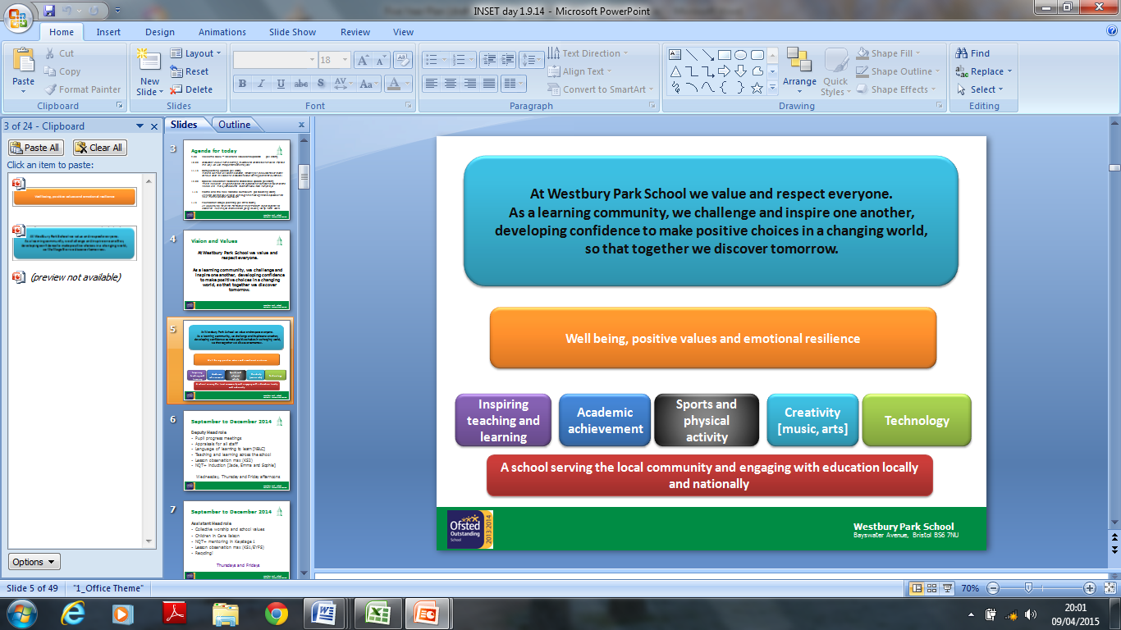

Fig 1: Westbury Park School Vision Diagram [2010]

School Values
Love of learning
- Enjoying learning and taking pride in our work
- Working hard and trying our best
- Developing interests and talents within and beyond the classroom
- Looking at mistakes as learning opportunities
- Sharing with others the excitement of new ideas and experiences
- Celebrating each others’ achievements
Respect
- Respect for others regardless of any differences
- Encouraging self respect and developing empathy for others
- Being polite to others
- Listening to and being considerate of the opinions and needs of others
- Caring for the environment in school, around Westbury Park, throughout Bristol and the world
Kindness
- Being fair and friendly to everyone
- Sharing willingly
- Treating others as we would like to be treated
- Remembering kind hands and feet and words
- Knowing when to compromise
Forgiveness
- Realising when we have done something wrong
- Saying sorry and really meaning it, so we can start again
- Trying our hardest to forgive others
Trust
- Being open and honest
- Feeling safe and secure
- Showing loyalty to our friends appropriately
Responsibility
- Knowing when to ask for help
- Being ready to learn
- Being determined and not giving up
- Listening and trying to understand
- Learning to make the right choices Fig 2: Westbury Park School Values [2014]

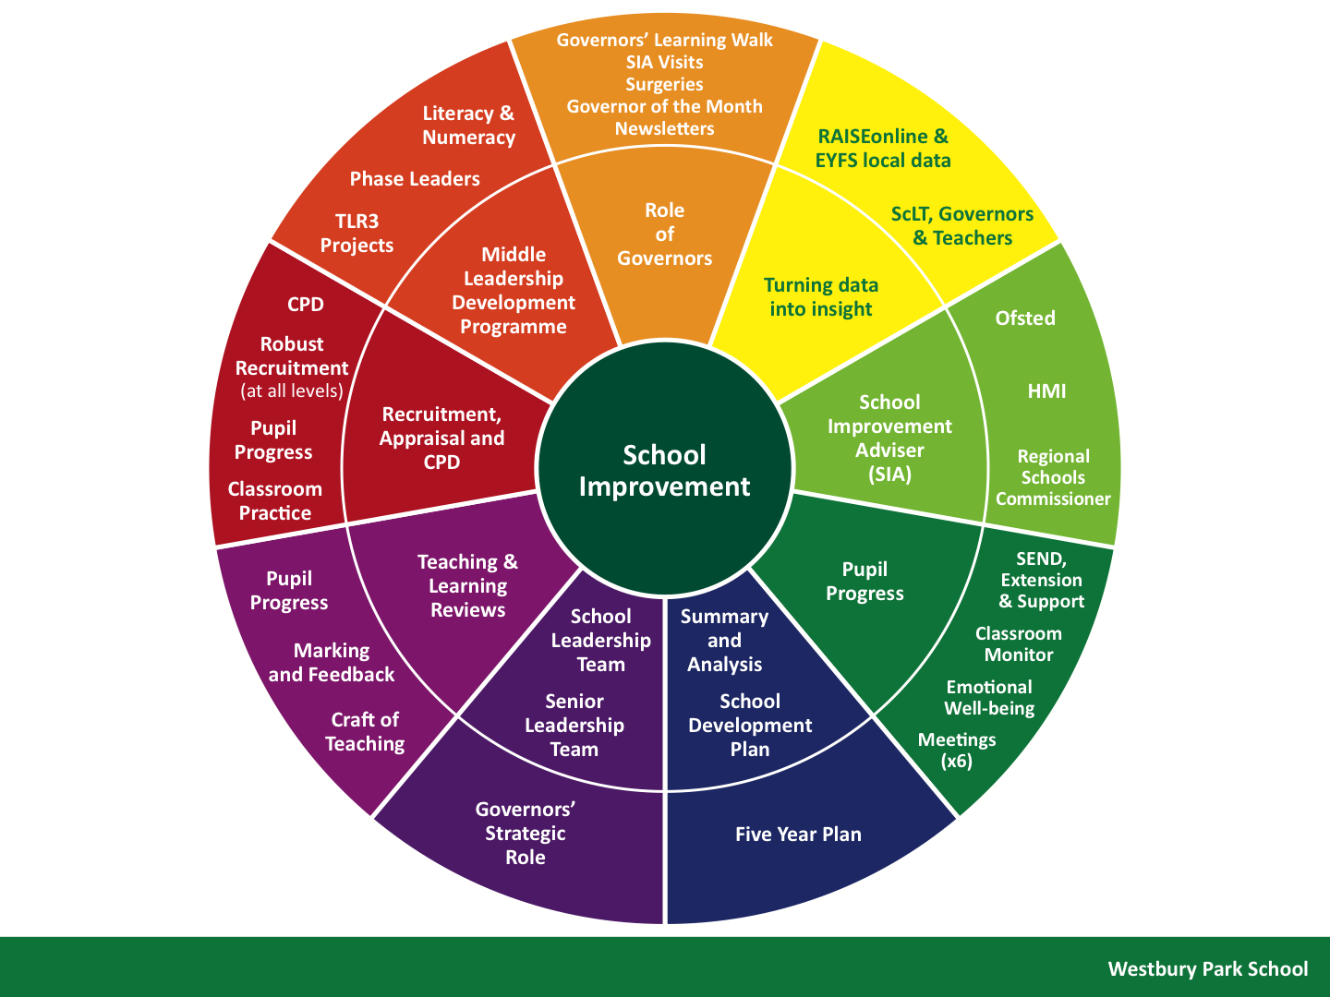

Fig 3: Westbury Park School Model for School Improvement [2015]

Experiences & Enrichment Offer

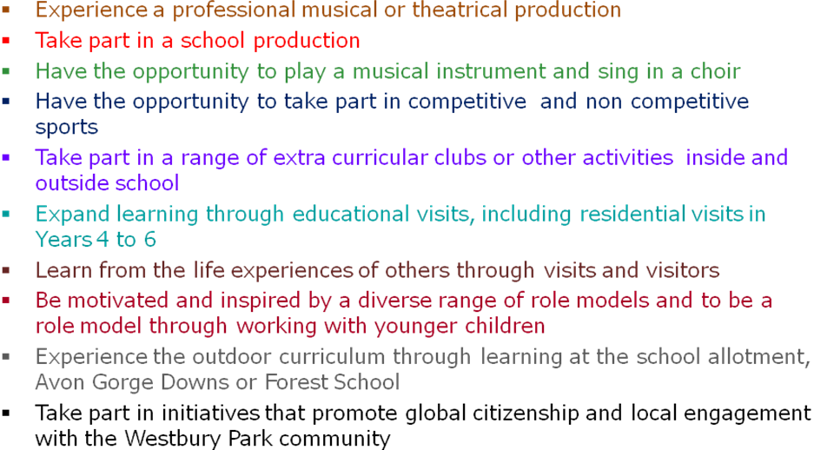

Fig 4: Westbury Park School Core Offer for Experiences and Enrichment [2014]

Westbury Park School

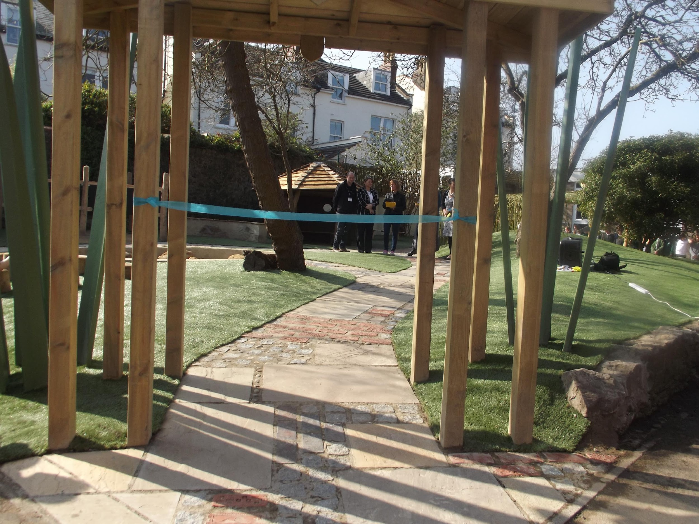

Five Year Plan
2015 to 2020

At Westbury Park School we value and respect everyone. As a learning community,
we challenge and inspire one another, developing confidence to make positive choices
in a changing world, so that together we discover tomorrow.

Prepared by members of the School Leadership Team, staff, Governors, parents and children between January and March 2015.
This plan was devised using our knowledge and understanding of education at the time but we are aware that the educational landscape may
change over the course of the next five years and therefore the plan may need to be refreshed in the light of these changes.

